

Functional Area: 31 Access MTM Account

Screen Specifications

Document History
Version | Date | Description | Name
0.1 | 19/03/2006 | Initial draft | Nicholas Cole
0.2 | 29/03/2006 | Review with the business. The behavior has changed when the CSA accesses MTM. There is now a CSA portal Advice screen which will handle exceptions when accessing MTM. | Nicholas Cole
0.3 | 04/04/06 | Baselined by Business | Nicholas Cole

1.1.1 Screens 3
1.1.1.1 Review MTM Profile (Access My T-Mobile Tile) 3
1.1.1.2 Error Message (Pop Up Window) 4
1.1.1.3 System Behavior 7

Screens

Review MTM Profile (Access My T-Mobile Tile)
This tile is displayed on the Review MTM Profile screen and will allow the CSA to navigate to MTM to view the customer MTM profile.

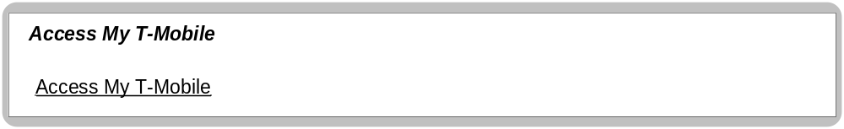

Business Logic Content
Name | Type | Description/Condition
Access My T-Mobile | Screen Title | The title of the screen

Links
Name | Destination | Description/Condition
Access My T-Mobile | MTM landing Page (Pop up window) | Successful Access to MTM  This link will;  - Fetch the profiles username and password.  - Ask MTM to validate the login credentials  - Display the MTM application in a pop up window. The system should behave exactly how it would normally when a MTM customer logs in.  - Allow read only access to the MTM account.
Access My T-Mobile | Advice Screen (Pop up window) | Unsuccessful Access to MTM.  This link will;  - Fetch the profiles username and password.  - Ask MTM to validate the login credentials  - Display the Advice screen as one or more the below exceptions have occurred.  Exceptions – System Error, Outstanding OTP, Temporary/Permanent lock on the MTM profile, Latest terms and conditions not accepted.

Validation
None

Advice Screen (Pop Up Window)
This pop up screen will be displayed when an exception occurs while trying to access the users MTM account.

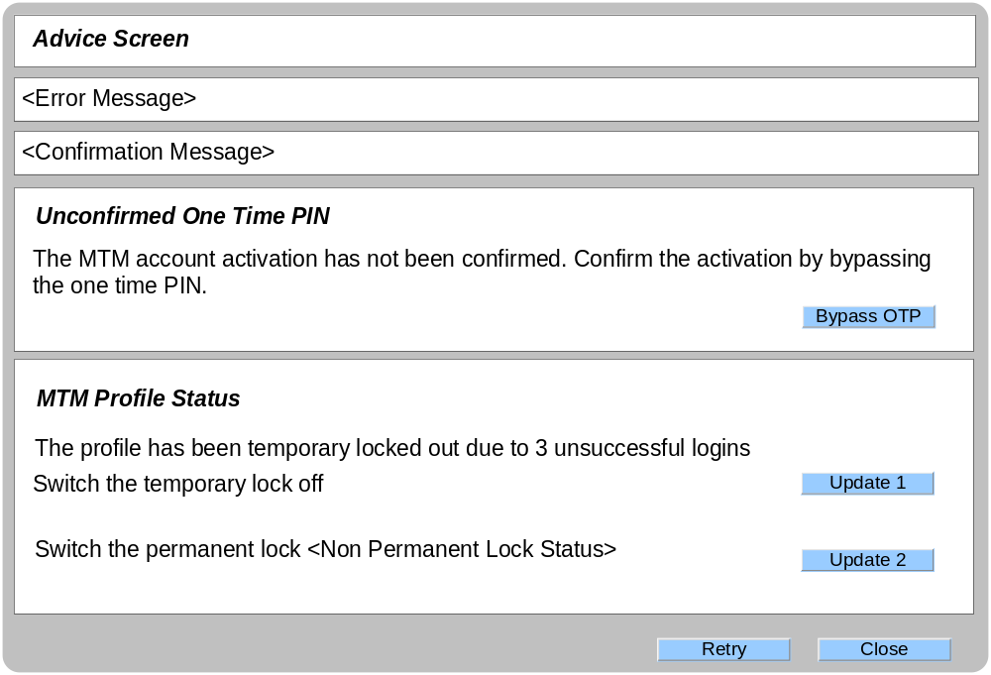

Business Logic Content
Name | Type | Description/Condition
Advice Screen | Screen Title | The title of the screen
Error Messages | Dynamic Text | The following error messages will be displayed on entry if the exceptions have occurred;  If the OTP (Profile Activation) is outstanding  Message = “The OTP must be bypassed before MTM access can be gained”  If a temporary lock (MTM logging) is applied to the MTM account  Message = “The temporary lock must be removed before MTM access can be gained”  If a permanent lock (MTM Profile) is applied to the MTM account  Message = “The Permanent lock must be removed before MTM access can be gained”  If the latest terms and conditions have not been accepted.  Message = “The user must log into MTM and accept the terms and conditions. Until this happens, there will be no access to MTM via the CSA Portal”  If a system error has occurred  Message = “The system has encountered an error, please try again later.”  The Error Messages will be displayed if any of the validation rules are not met.  If the OTP bypass was unsuccessful  Message = “The One Time PIN bypass has been unsuccessful, please try again later.”  If the temporary lock update is unsuccessful;  Error Message = “The temporary lock update has failed, please try again later.”  If the permanent lock update is unsuccessful;  Error Message = “The permanent lock update has failed, please try again later.”
Confirmation Messages | Dynamic Text | The confirmation Messages will be displayed when a successful update occurs;  If the OTP is successfully bypassed:  Message = “The One Time PIN has been confirmed.”  If the temporary lock is successfully updated:  Message = “Temporary lock has been removed.”  If the permanent lock is successfully updated:  Message = “Permanent lock has been successfully updated.”
Unconfirmed One Time PIN
This tile is only displayed if there is an unconfirmed one time PIN for the MTM account activation. This area will allow the user to bypass the OTP.

MTM Profile Status
This tile only displayed if 1 or more of the below scenarios occur;
- There is a temporary lock on the MTM profile (3 incorrect loggings)
- There is a permanent lock on the MTM profile.

This will allow the user to manage the temporary and permanent locks on the MTM account.

Links
Name | Destination | Description/Condition
Bypass OTP | Advice Screen | The Advice screen will be reloaded with either a confirmation message or error message. This link will confirm the OTP for the associated MTM account and remove the temporary lock (if one exists).  When the screen reloads, it must reflect the changes made by this link.
Update 1 | Advice Screen | The advice screen will be reloaded with either a confirmation message or error message. This link will turn off the temporary lock on the MTM account  When the screen reloads, it must reflect the changes made by this link.
Update 2 | Advice Screen | The Advice screen will be reloaded with either a confirmation message or error message. This link will turn on/off the permanent lock on the MTM account  When the screen reloads, it must reflect the changes made by this link.
Retry | MTM Logged in landing screen | Successful Access to MTM  This link will;  - Fetch the profiles username and password.  - Ask MTM to validate the login credentials  - Display the MTM application in a pop up window. The system should behave exactly how it would normally when a MTM customer logs in.  Allow read only access to the MTM account.
Close | Destroys the pop up. | This link will close the pop up window.

Validation
Name | Description/Condition
Retry Button | This button will be available when the following criteria has been met;  - No outstanding OTP’s (Profile Activation)  - No temporary or permanent locks  This button must not be available when;  - There is an outstanding OTP (Profile Activation)  - There is a temporary or permanent lock on the MTM profile  - A system failure error has occurred  - The latest Terms and conditions have not been accepted.

System Behaviour

This area will explain the behavior when the CSA Portal invokes MTM. The diagram below shows the potential scenarios a CSA could experience when accessing MTM via CSA Portal.

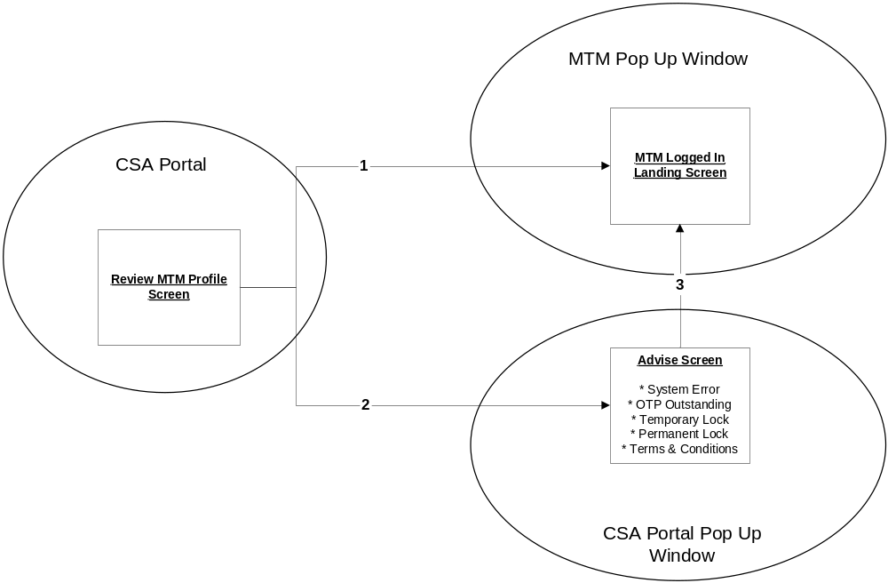

Key | Description
1. | Review MTM Profile to MTM Logged In Landing  The system will fetch and validate the user’s login credentials.  The username and password are accepted and the MTM logged in landing page is displayed.  This should be exactly what the customer would see if they logged into MTM
2. | Review MTM Profile to Advice Screen  The system has found 1 or more outstanding parameters which stop the user logging into MTM. These are as follows;  System Error  - This scenario will occur when there is a backend system error and the login credentials cannot be validated. The CSA will NOT have an option to proceed to MTM. Instead the relevant message will be displayed on the advice screen.  OTP Outstanding  The OTP for Profile activation is outstanding. The Advice screen will be displayed and the CSA will have the option to bypass the OTP.  Temporary Lock  A temporary lock is currently applied on the user’s profile. The Advice screen will be displayed and the CSA will have the option to remove the temporary lock.  Permanent Lock  A permanent lock is currently applied on the user’s profile. The Advice screen will be displayed and the CSA will have the option to remove the permanent lock.  Terms & Conditions  The latest terms & conditions have not been accepted. The CSA will NOT have an option to proceed to MTM. Instead the relevant message will be displayed on the advise screen
3. | Advice Screen to MTM Logged In Landing  If the outstanding OTP (Profile Activation), Temporary lock and Permanent lock have been successfully removed via the Advice screen then the CSA can navigate to MTM.  Note: If there is a system failure or the terms and conditions have not been accepted, then the CSA will not be able proceed to MTM.

Assumptions
- MTM will be run in Read Only Mode, when being accessed via CSA Portal
- An audit will be created when a CSA accesses a MTM account. This audit will contain the agents user id.

